Test Cases for Facebook Login Page

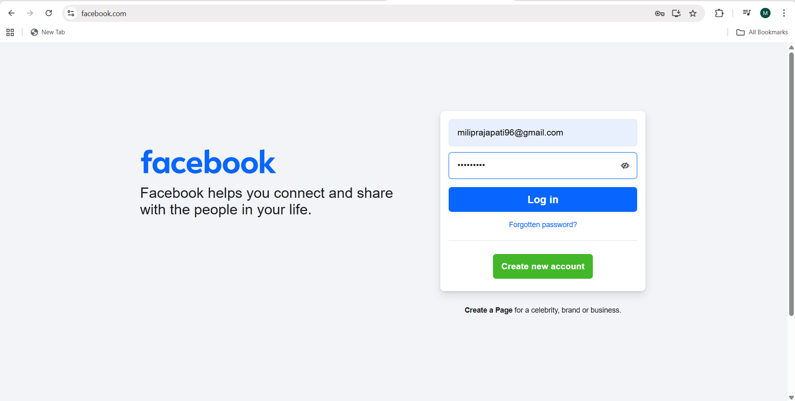
https://www.facebook.com/

TC 1: Verify that the URL of the login page opens when you hit the URL (“https://www.facebook.com/”).
Mob app: TC 1: Verify that the login screen opens when the application is launched.

TC 2: Verify that the Facebook logo is present.
TC 3: Verify the color, shape, font, size, and position of the logo.
TC 4: Verify whether the tagline is present or not.
TC 5: Verify that the font, position, and color of the tagline.
TC 6: Verify that there are no spelling, grammar, and punctuation errors in the tagline.

TC 7: Verify that all required labels, input fields, text, and links are present.

TC 8: Verify that the website or login page is responsive on all devices (Mobile, Laptop, PC, Tablet). ( Responsive Testing)

TC 9: Verify that all buttons, links, text, and input fields are properly aligned.

TC 10: Verify the size of all buttons, link text, and input fields.

TC 11: Verify that the functionality should work in different browsers (Cross Browser Testing ).

TC 12: Verify that the tooltip is present or not.

TC 13: Verify that the placeholder is present or not.

TC 14: Verify that the login page is responsive according to different
Screen size. (Responsive Testing )

Developer tools
- Ctrl + Shift + i
- Right-click and select the Inspect option
- Three dots -> More tools -> Dev tools

TC 15: Verify that the user can input a username.

TC 16: Verify that the user can enter a password.

TC 17: Verify that the password is masked or encrypted when entered.

TC 18: Verify that the password is visible when the eye button is tapped and then becomes encrypted on a double tap.

TC 19: Verify the minimum and maximum allowed character limit of
Username/Email.

TC 20: Verify the Min and max allowed character limit for the password field.

TC 21: Verify the redirection of links present in the footer section.

TC 22: Verify that the user cannot log in with an empty Username and Password.

TC 23: Verify that the correct error message should be displayed when the user enter blank email and password.

TC 24: Verify that the user should not be able to log in with a blank email/username and a valid password.

- Invalid Credentials
- The email and password combination are not correct
- Email is a mandatory field.
- Email id cannot be blank.
- Authentication Error.

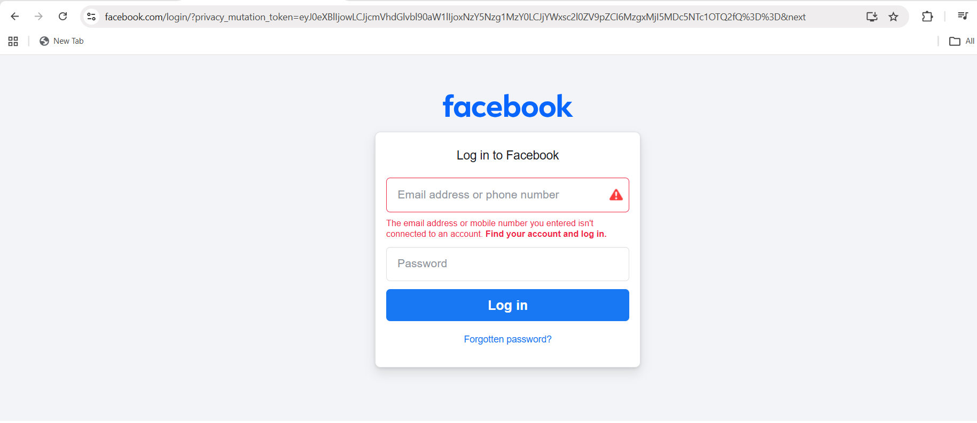

TC 25: Verify the error message when the user enter blank email and a valid password.

Email | Blank | Blank | Invalid | Valid | Blank
Password | Blank | valid | Blank | Blank | Invalid

Email | False | False | False | True | False
Password | False | True | False | False | False

TC 26: Verify that the user should not be able to log in with the old password after the reset.

TC27: Verify that the user should be able to log in with a new password.

TC 28: Verify that the user cannot set an already used password as a new password.

TC 29: Verify that the user should not be able to set username, email, or phone number as a password.

TC 30: Verify that the password should match the expected criteria ( one Lowercase, one uppercase, 1 Special character, 8 digits long )

TC 31: Verify that the forgotten password link is working properly.

TC 32: Verify that the user should not be able to reset the password with a wrong email address.

TC 33: Verify that the correct error message should appear when resetting the password with the wrong email/username.

TC 34: Verify that the user should enter the correct email or username to reset their password.

TC 35: Verify the max number of unsuccessful login attempts allowed.

TC 36: Verify whether captcha, OTP, 2FA OR MFA is enabled or not.

TC 37: Verify whether multiple sessions are allowed or not.

